**EgFWD – Udacity**

**Embedded Systems Professional Track**



**On Demand Traffic Light Control Final Project**

*Project Documentation*

*By: Mohamed Ahmed El Sherbini*

**Introduction:**

This project aims to control traffic lights using LEDs and a button. The system has two modes - normal mode and pedestrian mode. In normal mode, traffic lights for cars change from red to yellow to green and then back to yellow and red. Meanwhile, pedestrian lights remain red until the button is pressed. In pedestrian mode, traffic lights for cars are red and the pedestrian lights change from red to yellow to green and then back to yellow and red. This cycle is repeated six times, after which the system switches back to normal mode.

**Hardware Description:**

The system has LEDs for both car and pedestrian traffic lights. It also has a button to switch between normal and pedestrian modes. The LEDs are connected to specific pins of a microcontroller. The button is also connected to a pin of the microcontroller, and an interrupt is triggered when it is pressed.

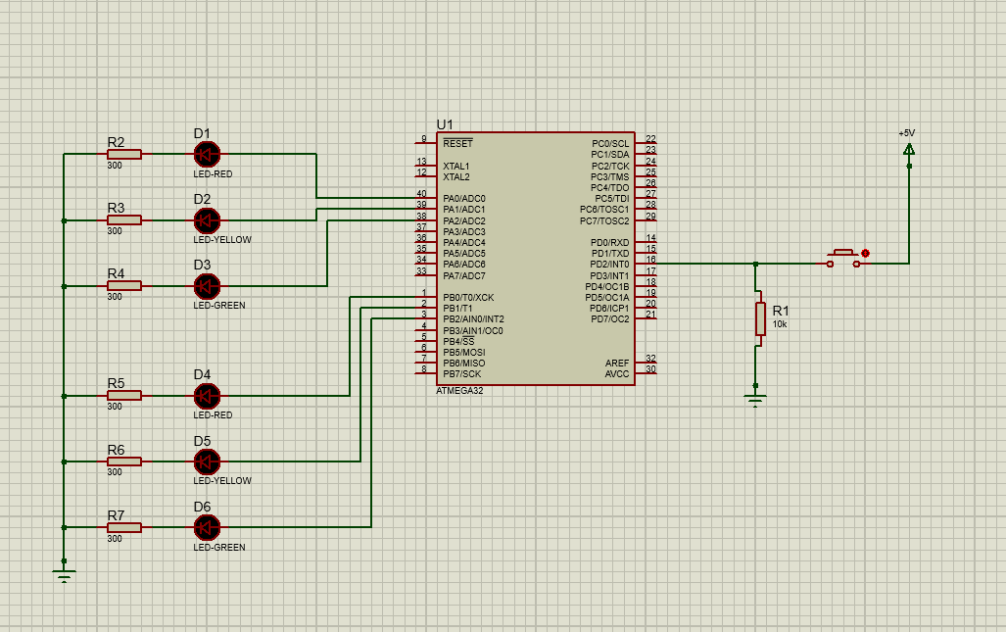

**Software Description:**

The software for this project is written in C programming language. The program includes a function to initialize the LEDs and the button. The program also uses a timer to delay certain actions. The timer is initialized in the initialization function. The program includes another function to start the system, which controls the traffic lights' behavior.

**Operation Description:**

When the system is turned on, it starts in normal mode. In normal mode, the program turns on the red LED for pedestrian traffic and switches on the car's LED to green. After a specific time interval, the program switches the car's LED from green to yellow and then from yellow to red. Meanwhile, the pedestrian LED remains red. If the button is pressed during normal mode, the system will switch to pedestrian mode.

In pedestrian mode, the program turns on the red LED for car traffic and switches on the pedestrian LED to green. After a specific time interval, the program switches the pedestrian LED from green to yellow and then from yellow to red. Meanwhile, the car LED remains red. The cycle is repeated six times, after which the system switches back to normal mode.

If the button is pressed again during pedestrian mode, the system will switch back to normal mode. The program also has logic to handle button presses, which includes checking for the duration of the button press. If the button is held down for a specific duration, the system will switch to pedestrian mode. If not, the system will ignore the button press.

**Conclusion:**

This project demonstrates a simple implementation of traffic light control using LEDs and a button. The project can be used as a base for more complex traffic control systems or as a teaching aid for students learning about microcontrollers and programming.

**Flow Chart:**

